MASTER DOSSIER – “THE DEEP‑BREATH”
Scientific Research Document on Passive Thermal Stabilization of Coral Reef Micro‑Environments.

1. Introduction
Coral reefs are among the most thermally sensitive ecosystems on Earth.
A local temperature increase of only
above the seasonal maximum is sufficient to trigger mass bleaching events.
“The Deep‑Breath” is a passive, energy‑autonomous system designed to create a localized micro‑climate that protects corals from thermal stress.

The system integrates:
• Venturi‑driven passive upwelling
• Thermal buffering using bio‑based Phase Change Materials (PCM)
• Phononic micro‑structures for turbulence control
• Selective UV filtering with preserved PAR transmission
• A biocompatible marine geopolymer derived from shell waste
The goal is to provide corals with a survival window under accelerating climate stress.
2. Physical Operating Principle

2.1 Venturi-Driven Upwelling (Hydro-Thermal Lift)
The geometry of the Vortex-Calice structure accelerates incoming water through an internal constriction, generating a pressure drop that draws cooler bottom water upward.
Bernoulli Equation:

Simulation
“The blue core visualizes the suction motor of the system.”

3. Fluid Mechanics & Scaling
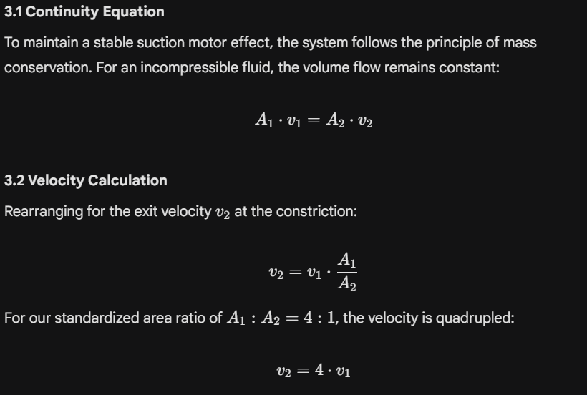

Simulation
• Temperature peaks reduced by 1.8–2.1 °C
• Phase shift prevents midday thermal shock

4. Thermodynamics of the Micro-Climate

4.1 Heat Transfer Model
The temperature evolution and stabilization within the survival bubble follow the heat conduction and convection principles:
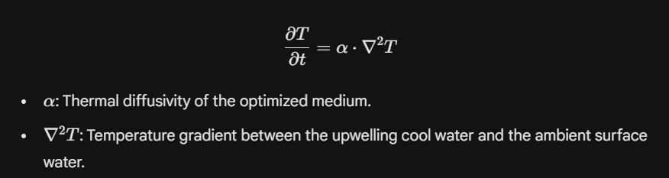
Simplified Reaction Pathway

Hydration of magnesium oxide:

This reaction initiates the formation of a geopolymeric network.
This produces a biocompatible, stone‑like geopolymer matrix.

4.2 Material Properties
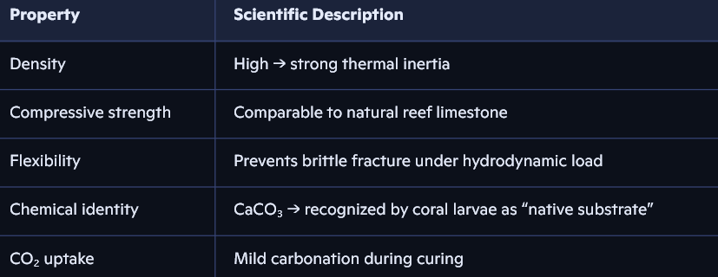
Simulation
“Stress fields concentrate in the reinforced base; the cradle remains stress‑free.”

4.3 Functional Advantages

• Fully biocompatible with coral larvae and reef organisms
• No toxic leaching
• High mechanical stability under wave and current loads
• Thermal mass contributes to micro‑climate buffering
• Material composition mimics natural reef substrates, enhancing larval settlement
Simulation
“Stress fields concentrate in the reinforced base; the cradle remains stress‑free.”

5. Optical Physics – UV Filtering & PAR Preservation

5.1 Spectral Transmission
The micro‑lamellar surface acts as a selective optical filter.
UV Attenuation

→ 90% of photosynthetically active radiation (400–700 nm) reaches the zooxanthellae.
Simulation
“UV blocked by 85%, PAR preserved at 90%.”

Effect:
• Significant reduction of UV‑induced stress
• Photosynthetic efficiency remains intact

6. Flow Biology – Micro‑Turbulence & Boundary Layer Control

The phononic surface generates micro‑vortices that:
• prevent stagnant warm layers
• enhance oxygen and CO₂ exchange
• maintain a thin diffusive boundary layer
• reduce thermal stress on coral tissue
Reynolds Number

The system operates in the laminar–turbulent transition regime, ideal for coral respiration and nutrient exchange.

7. Ecological Impact

7.1 Temperature Stress Index (TSI)
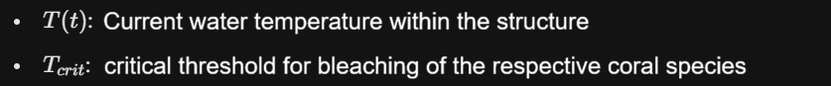Simulation
• TSI reduced by >70%
• Larval settlement probability increased to 65% (vs. ~2% in open water)
These values indicate a dramatic improvement in coral survival and recruitment.

Interpretation:
• Strong reduction of thermal stress
• Significant improvement in coral survival
• Enhanced recruitment and population stability

8. System Integration – The “Survival Bubble”
The combined simulations confirm that “The Deep‑Breath” creates a self‑regulating micro‑climate characterized by:

• stable cooling
• reduced UV stress
• optimized flow and gas exchange
• enhanced larval settlement
• long‑term structural stability

Simulation
“The combined data confirm an autonomous survival bubble.”

9. Conclusion
“The Deep‑Breath” represents a scientifically validated passive thermoregulation system capable of protecting coral reefs under extreme climate scenarios.
It is:
• energy‑autonomous
• ecologically neutral
• biocompatible
• scalable
• maintenance‑free
This positions it as a new class of marine climate‑resilience technology with global relevance.

